

**Contents**

**Details:**

# Requirement analysis

# Design documents

# Error Reports

# Testing Report

# Screenshots

**Page number:**

4

5

14

17

19

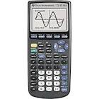

About the company:

The finance company called the Dimension Money is in preparation to establish a 3 in 1 calculator. Not only this calculator performs the basic standards but, it is able to convert from a standard calculator to two optional formats, the exchange rate and the interest rate. Each of them is uniquely designed to perform different calculations within their own fields.

Requirements:

Within the process of implementing the system, there are certain requirements needed.

Software developers (also known as programmers) are essential due to the implementation of the system. They are specialists who analysis and evaluate on the program. Therefore, for a visual calculator to be created, operate and return accurate results, software developers are needed for the job.

System Requirements:

Before implementing the program, there is several of software systems needed;

* Visual Studio 2012
* Microsoft visual studio 2010 tools for office runtime
* Microsoft.NET Framework 4.5
* Microsoft.NET Framework 4.5 SDK
* Microsoft ASP.NET MVC3
* Microsoft ASP.Net Web Pages
* Microsoft silver light
* Microsoft silver light 4
* Microsoft silver light 5 and
* Microsoft Windows 8 or 7 software package (optional)

Hardware Requirements:

Hardware which are required for the implementation of the program;

* Hard disk drive 500GB (or more)
* Memory of 4GB
* Intel core i7-3.0GHz
* 540M processor and
* External Hard drive 1TB



1. Dimension Calculator [Design 1]

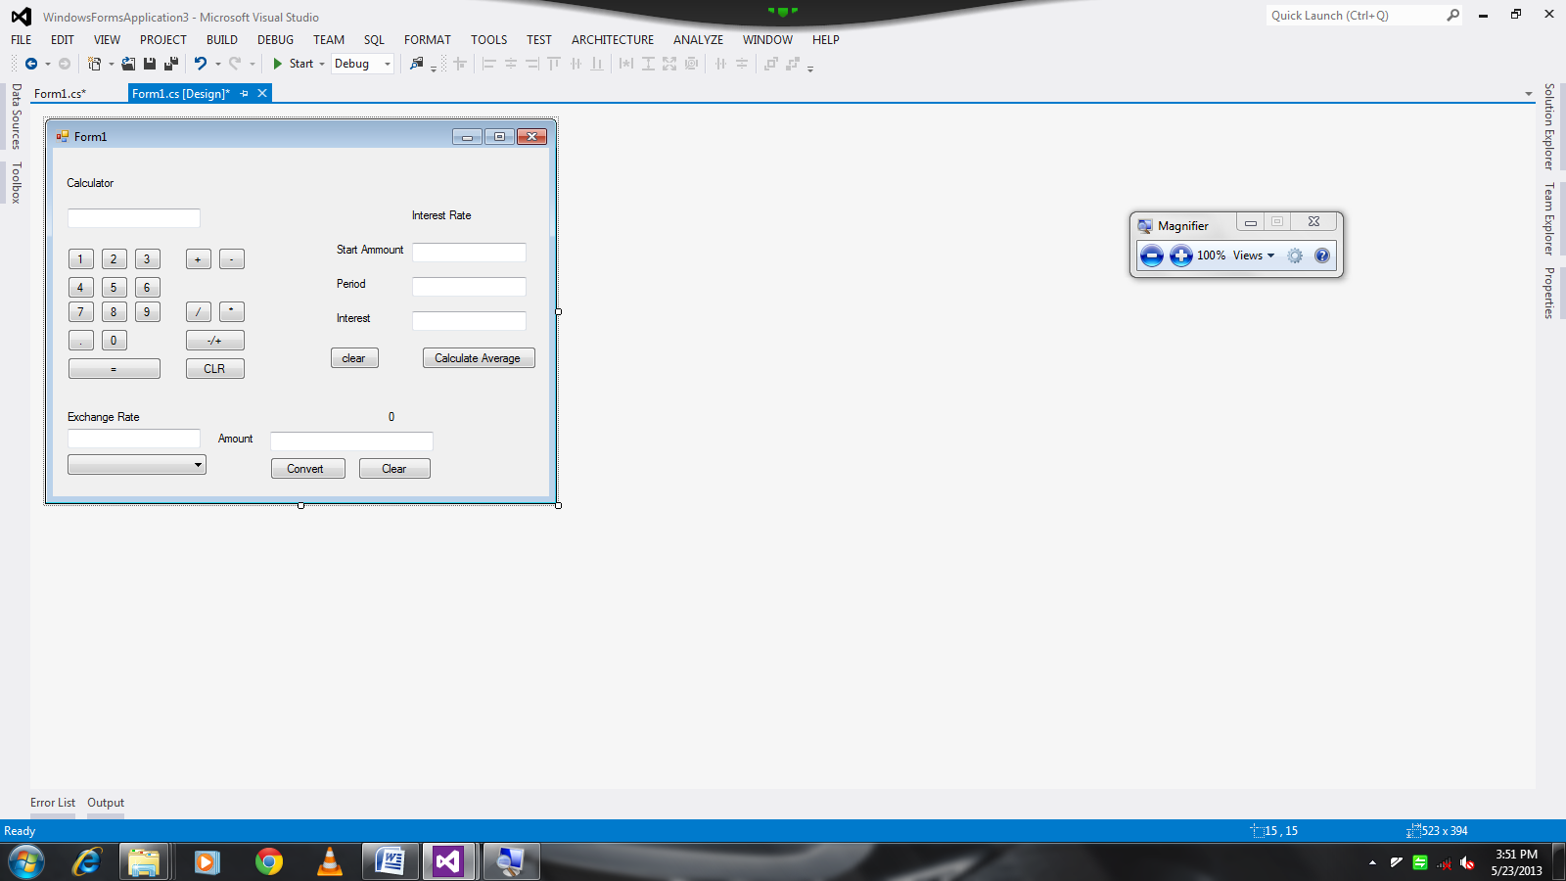

1. Dimension Calculator[Design 2]:

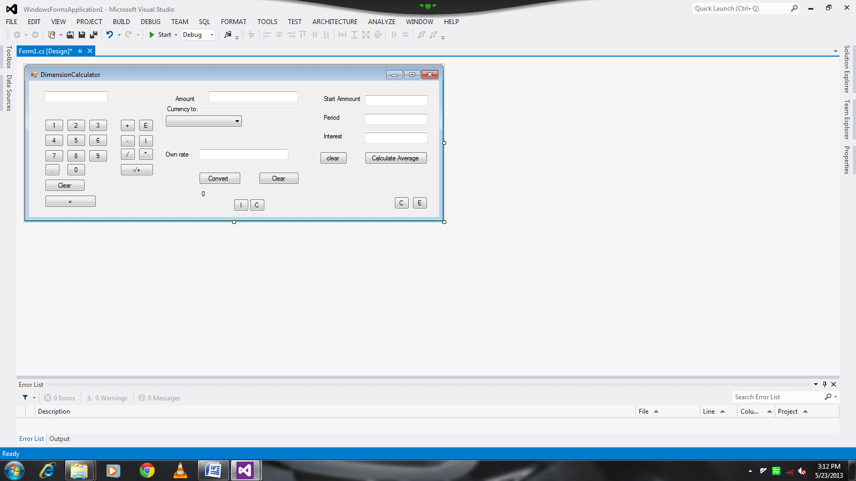

1. Dimension Calculator [Design 3] final:

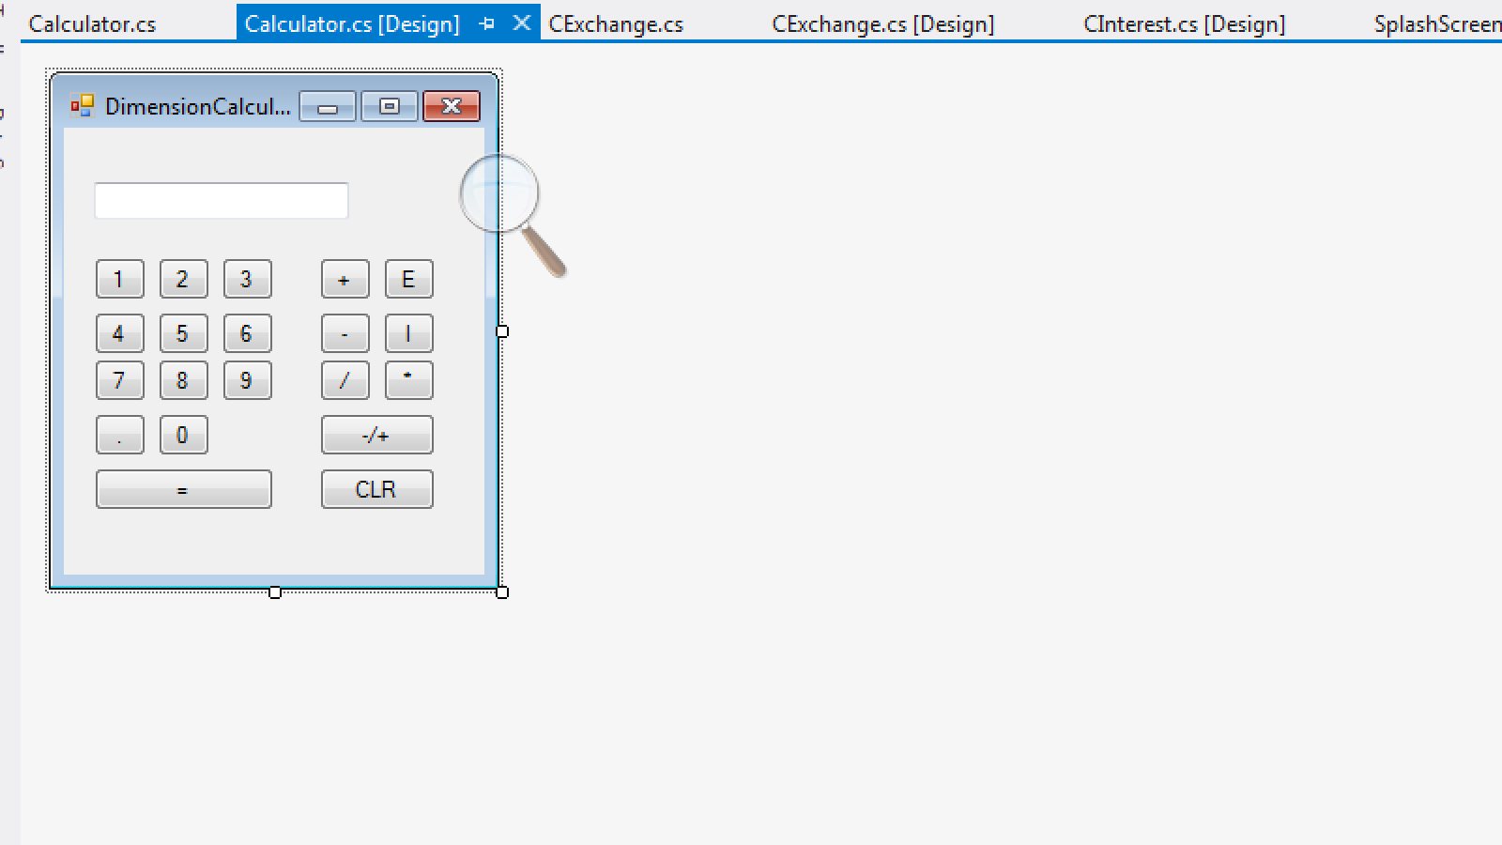 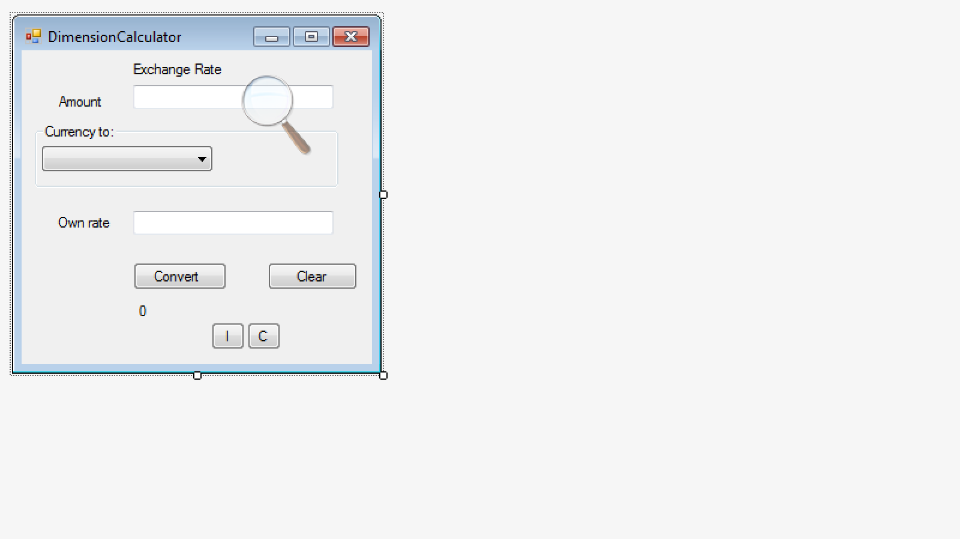 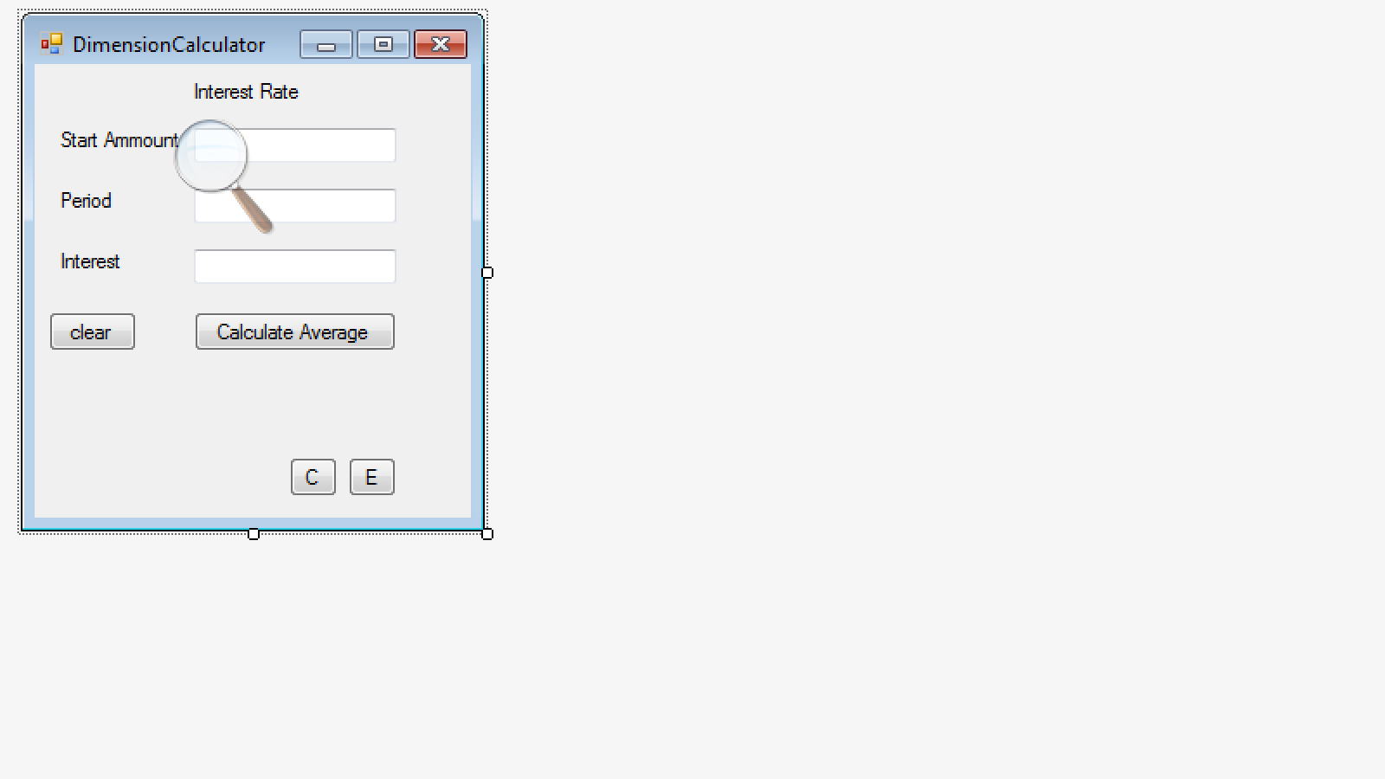



There are certain errors I encountered while implementing the program. Here are examples displayed below:

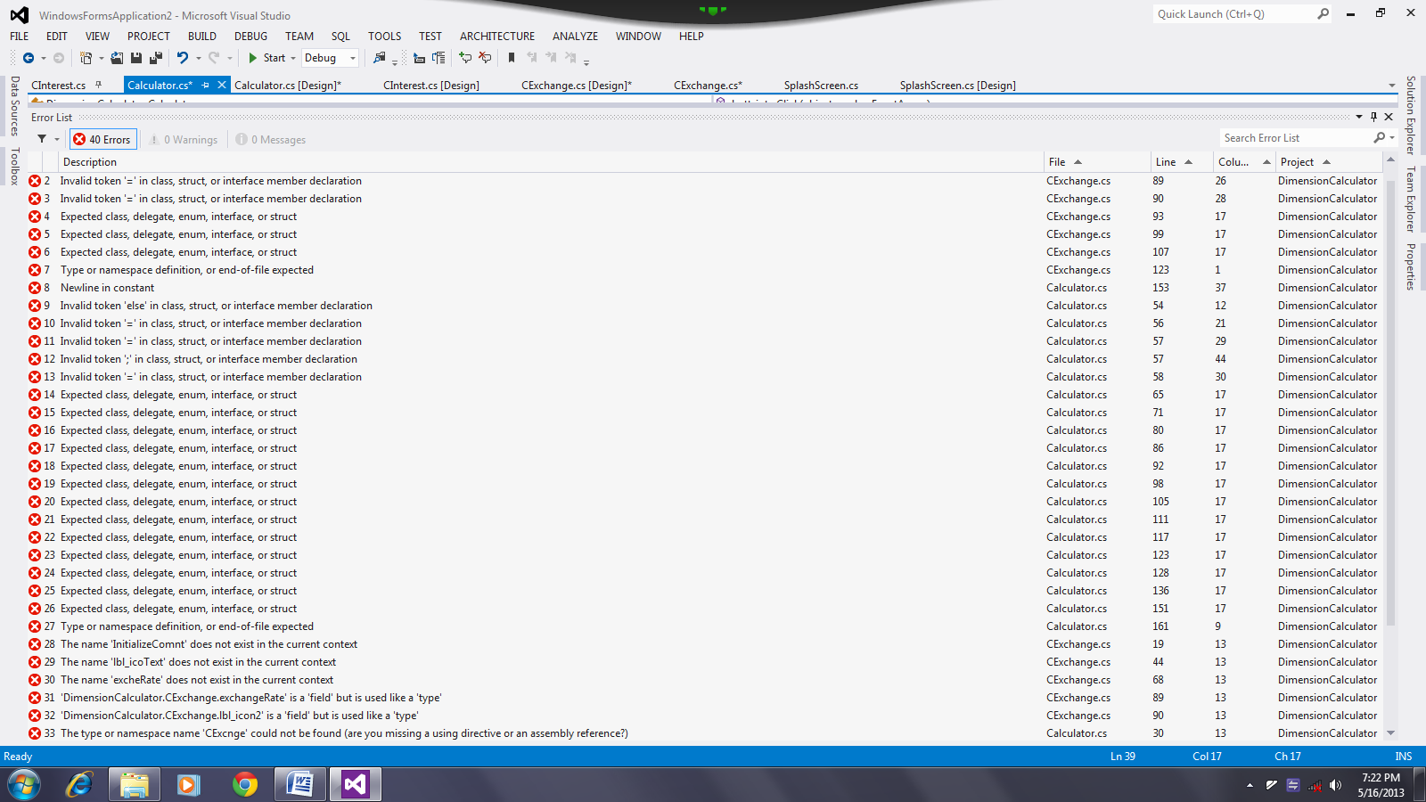

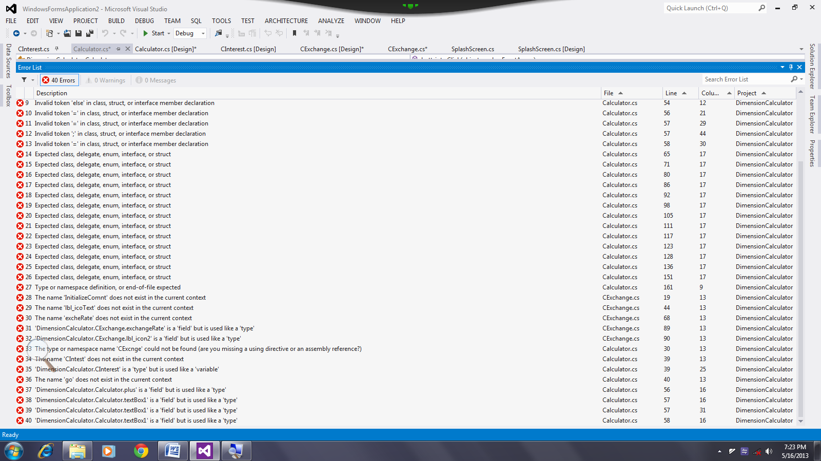



The Splash screen:

When I first run the program, a splash screen appears to which takes approximately 8 seconds when displayed. It then closes to open up the start-up program, the calculator.

The Calculator:

Moving on to the calculator, several buttons appear; the numeric buttons (ranges from 0 to 9); the arithmetical operators (the “+”, “-“,” /”,”*”,” +/-“,”.” and the “=” signs); the clear button (which is displayed as “CLR”); the “E” and “I” buttons and the textbox. By clicking on one of the numeric buttons, a number is displayed on the textbox. With certain operators, it works differently. As I press on the decimal button, the sign will appear on the textbox. But, as I press it the second time, the program doesn’t respond. This clearly shows that the decimal sign can only be displayed once per time on the textbox. By clicking on the positive and negative sign, a negative sign appears on the textbox which will represent a negative number. By clicking on it again, the sign suddenly disappears to which represents a positive number. Clicking on the addition, multiplication, subtraction and division buttons just after entering a number, the textbox screen becomes blank. This shows whatever operator I specified is in the process of initializing the equation. Thus, by entering another numeric value, I get an output result displayed on the textbox, after I have clicked on the equal’s buttons. Unlike other operators I’ve specified, when dividing by 0, an error message appears stating that I have “Attempted to divide by zero”. The “CLR” sign, as I mentioned, represents the clear button. Also, as the name implies, it clears away unwanted data displayed on the textbox thus putting the calculator to a default state as I click on it. The “E” and “I” buttons allow me to switch between programs. In this case, the “E” button will allow me to switch from the calculator to the exchange rate while the “I” to the interest rate. In addition, by pressing on any keys situated on the laptop, the program does not respond. Due to this reason, it prevents me from entering typed data from the keypads.

The exchange rate:

Within the exchange rate program, there are two textboxes, one for displaying the starting amount and the other for setting a currency amount. Unlike the calculator, this application allows me to input only numeric values on the keypads to either textboxes. The combo box which has the country “Lesotho” displayed and grouped within the “currency to” box, allows me to click on varies countries displayed as I click on it. In favor of picking the country “South Africa”, I enter in a numeric value on the top textbox and press the convert button. Subsequently, a result has been outputted just below the button accompanied with its currency symbol. Yet again, a “clear” button appears thus clearing the total amount along with the symbol and the displayed result on the textbox thus setting the program to default. As with the calculator, the exchange rate application allows me to switch between the interest rate (which will be the “I” button) and the calculator (which will be “C” button) when clicked.

The Interest rate:

As this program appears, there are similar features compared with the previous program to which I mentioned. It allows me to switch between the calculator and the exchange rate application by clicking on the “C” and “I” button. There is a clear button which practically does the same thing as with both the calculator and the exchange rate which is by clearing all three textboxes and the output result displayed below the “Calculate Average” button and setting them to default. As with the exchange rate, within all three textboxes I can only enter numeric values from the keypads. Finally, by filling all textboxes, I then press on the “Calculate Average” button which gives me a percentage result displayed below the button.



Splash screen:

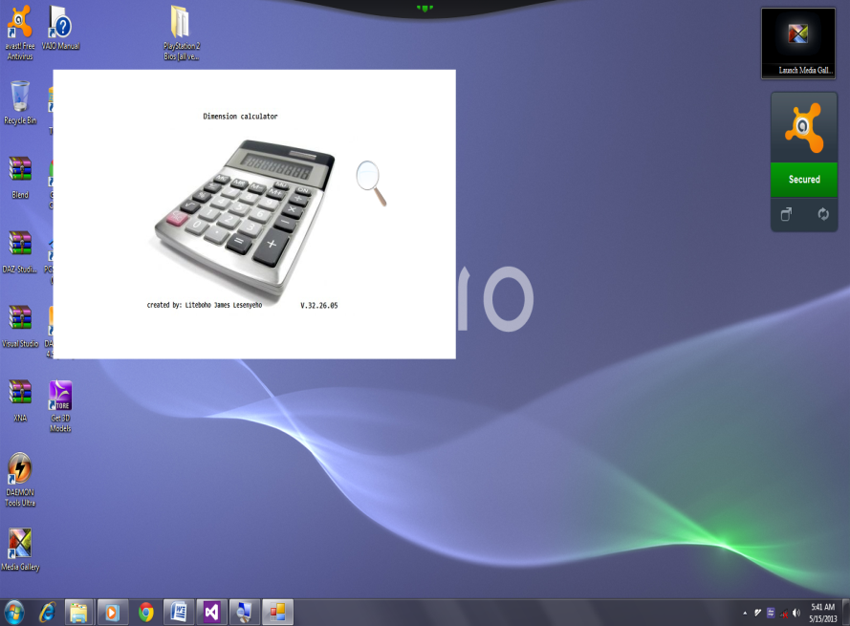

Calculator:

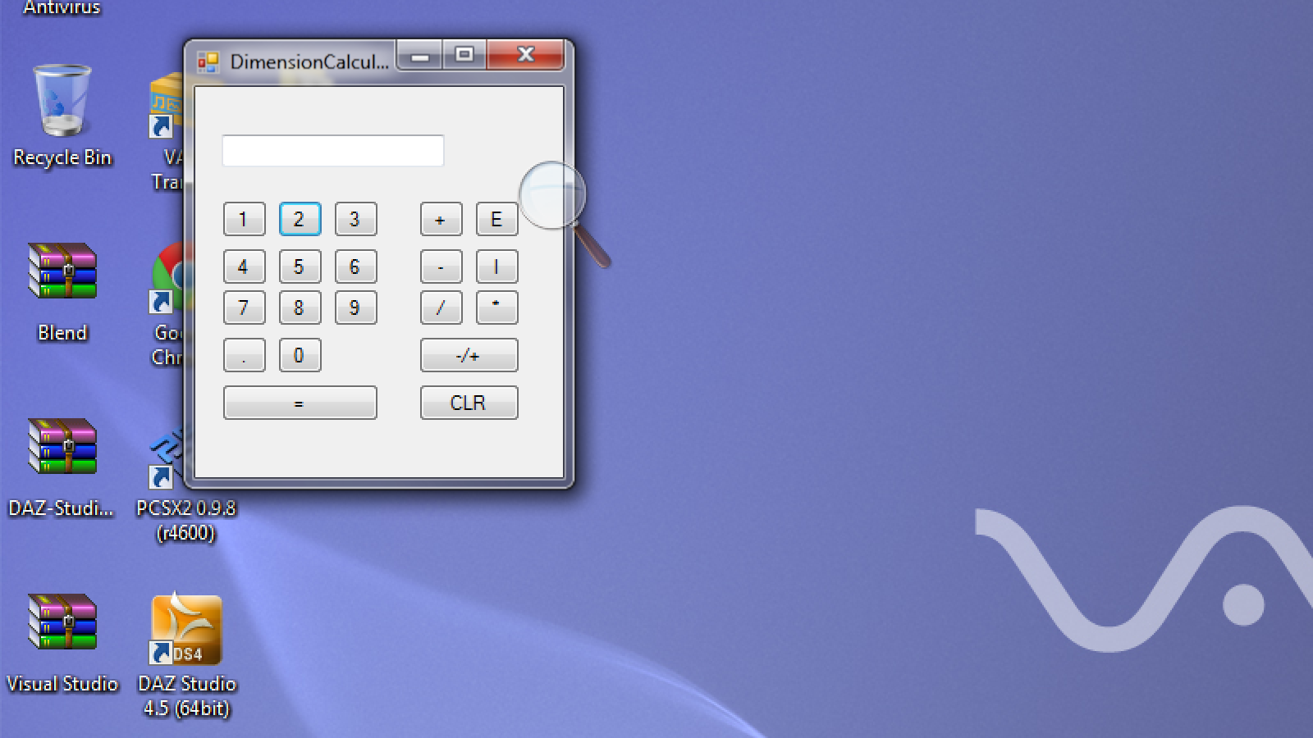 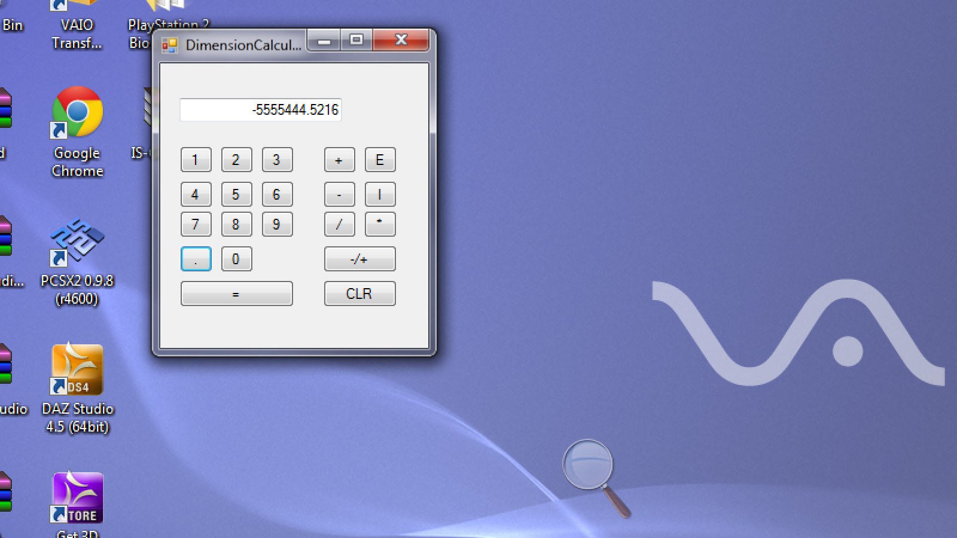

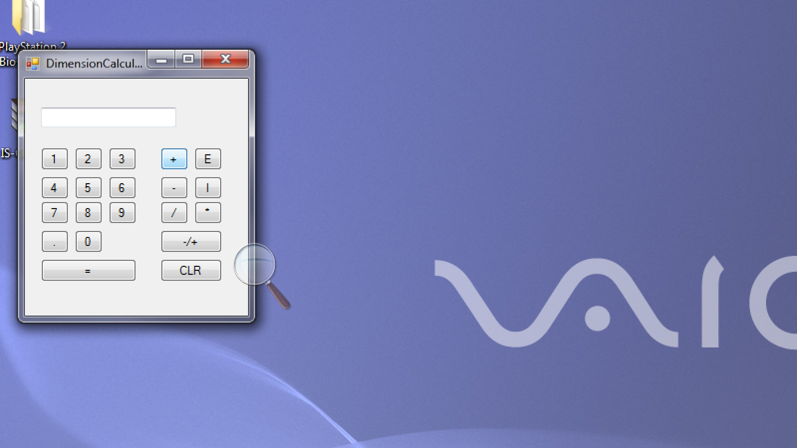 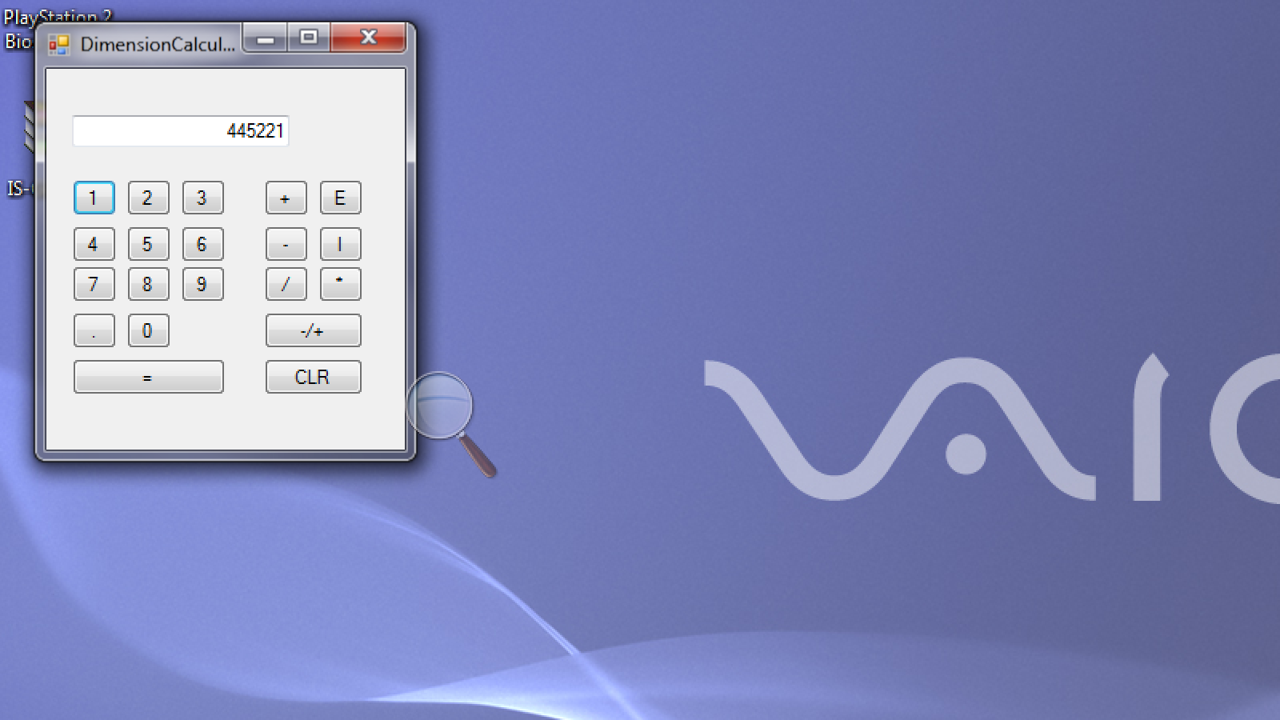

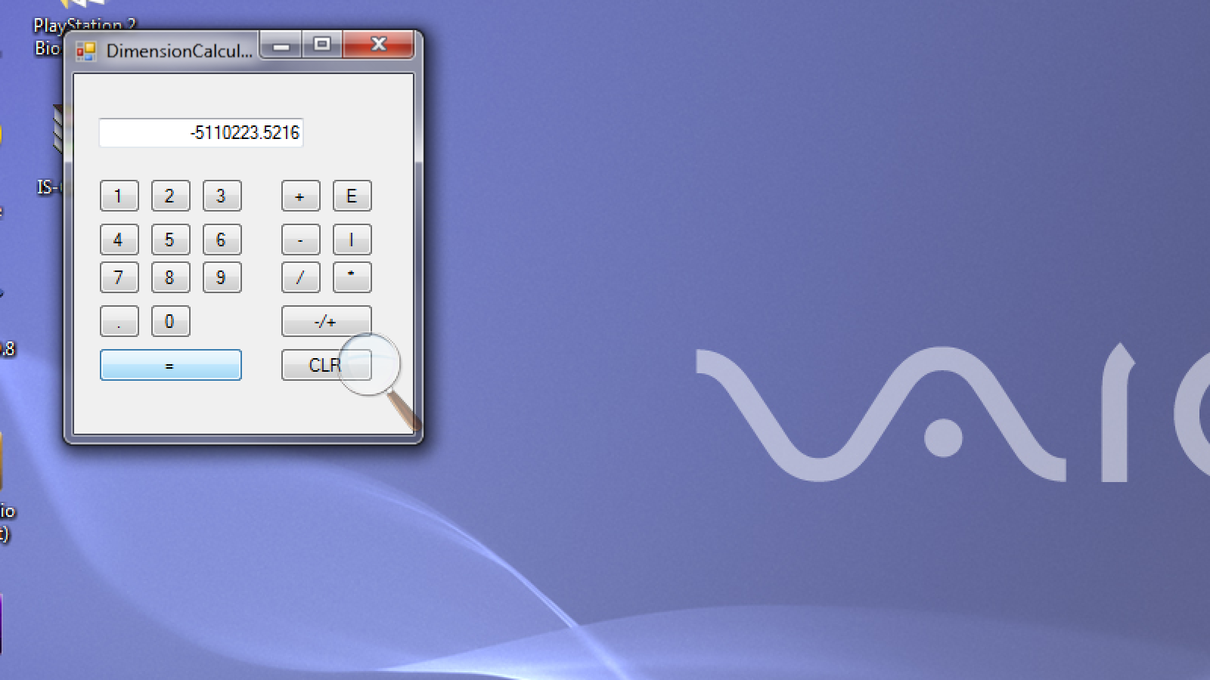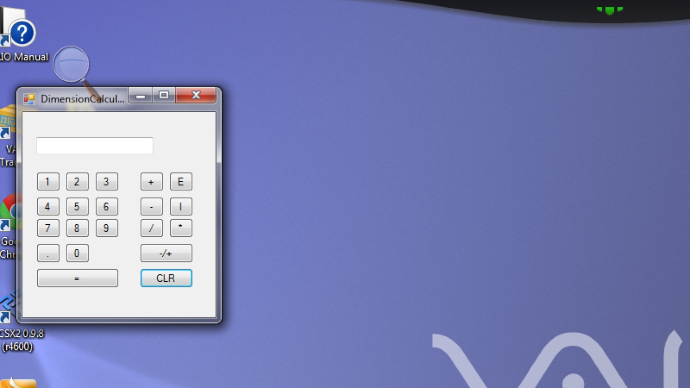

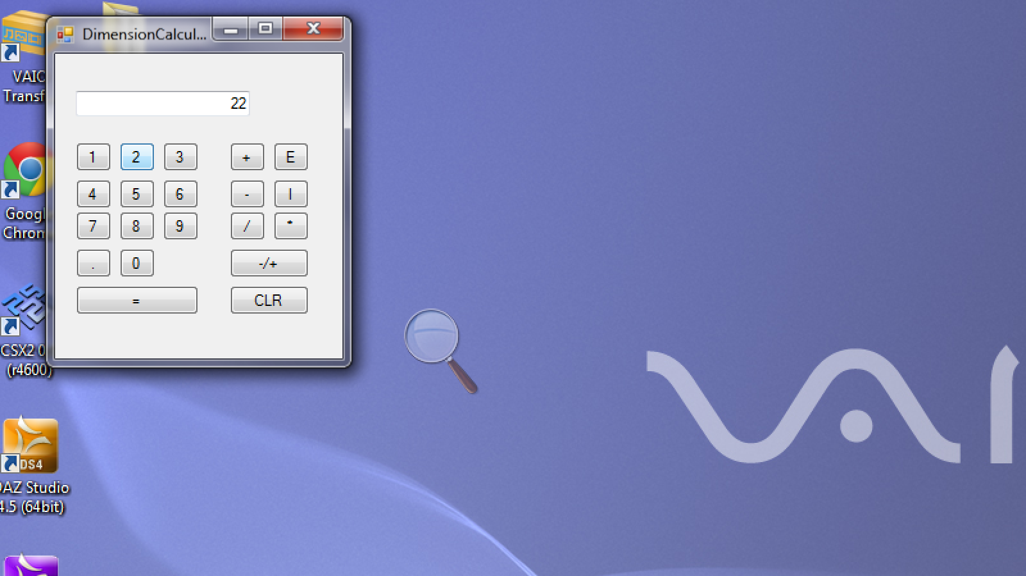 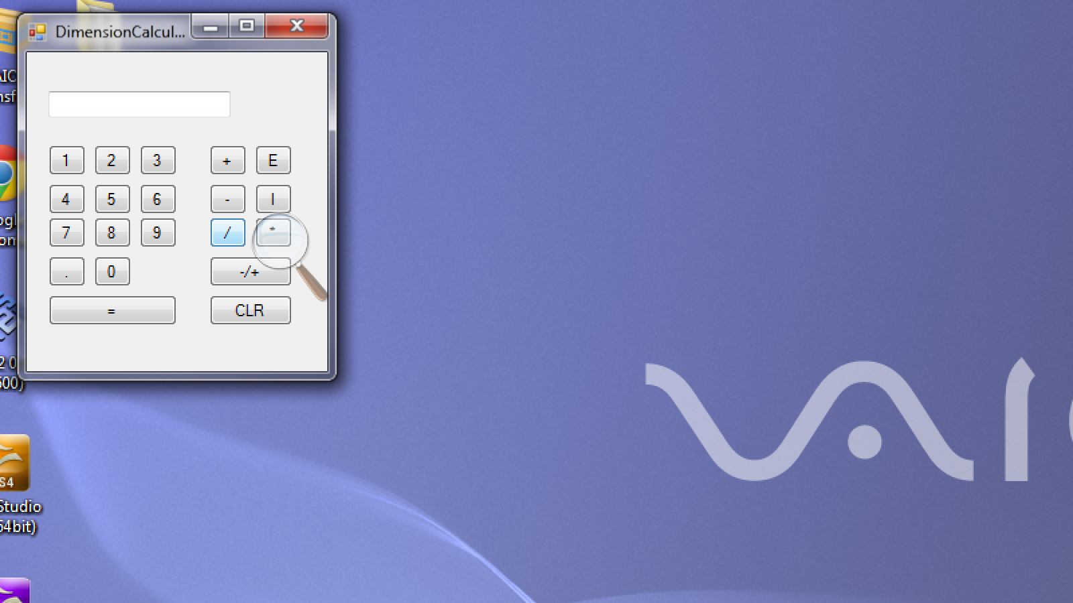

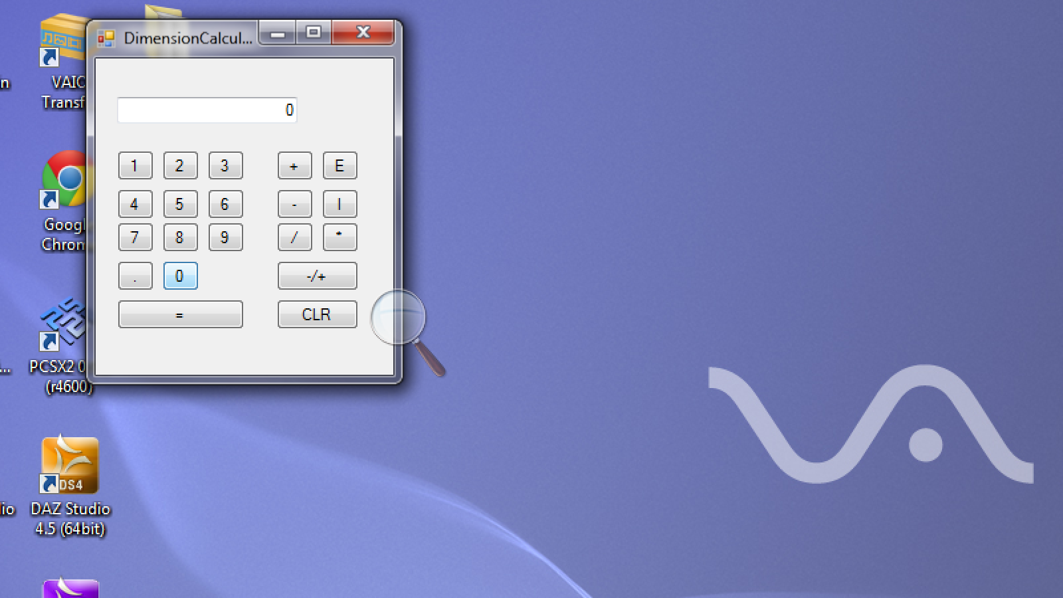 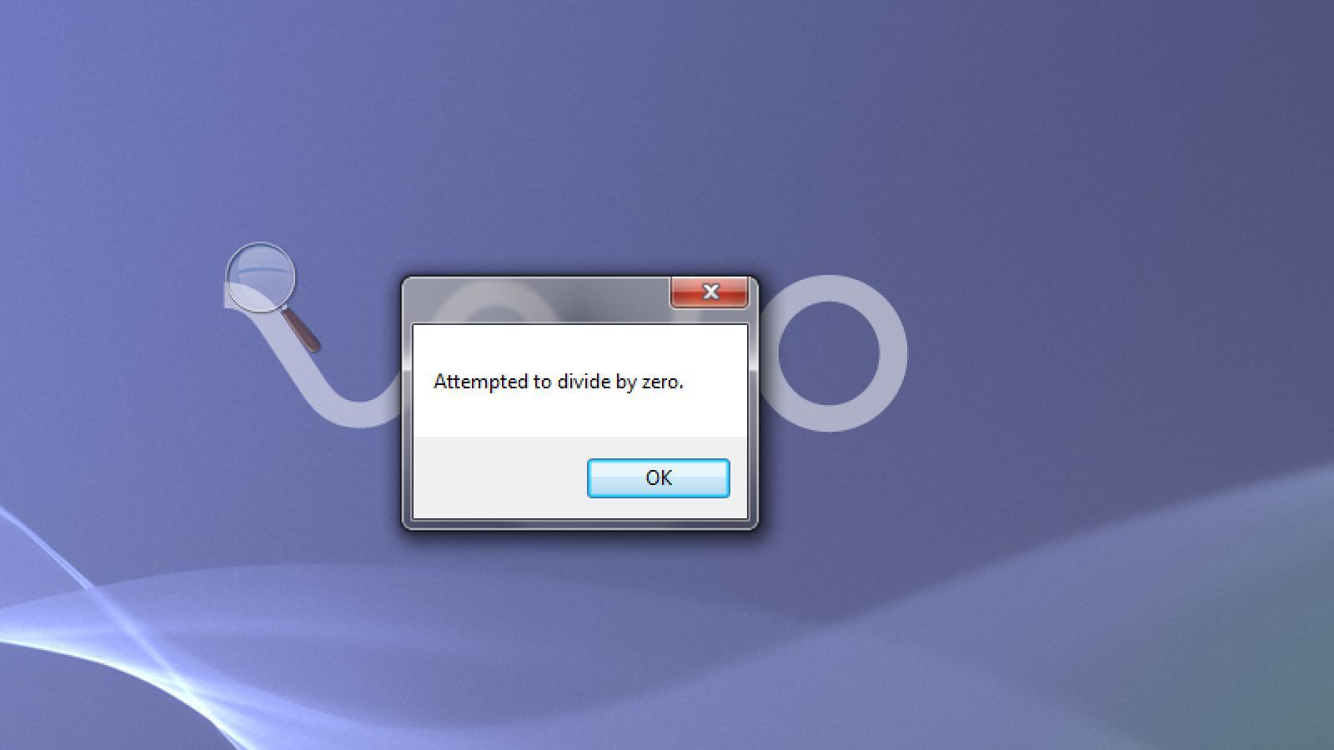

Exchange Rate:

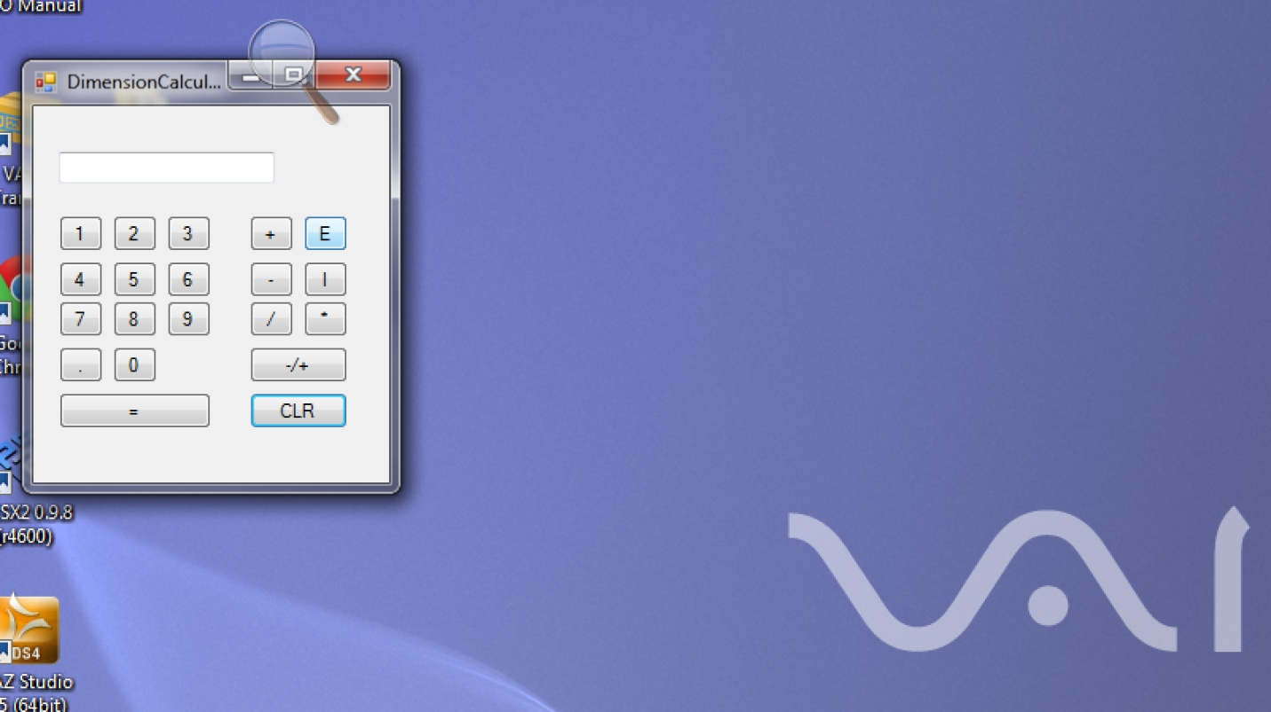 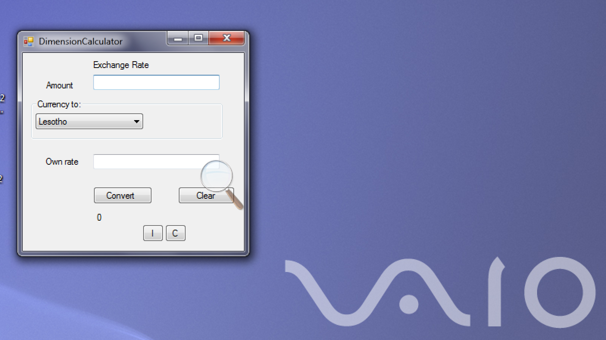

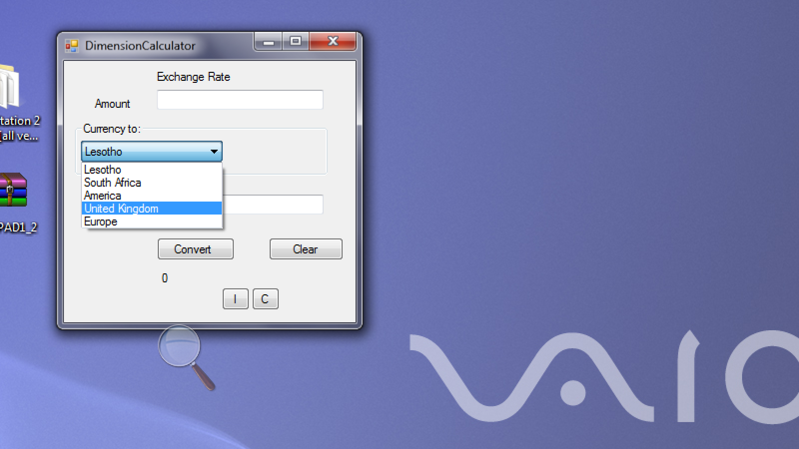 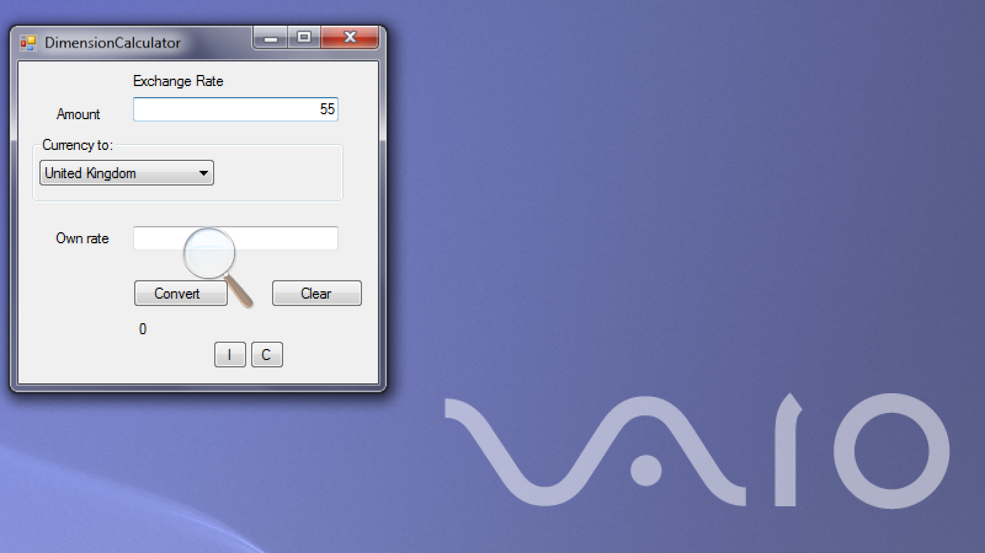

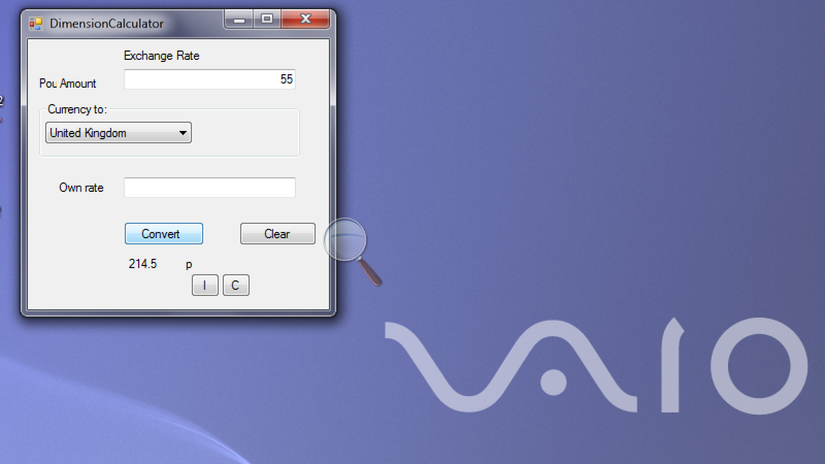 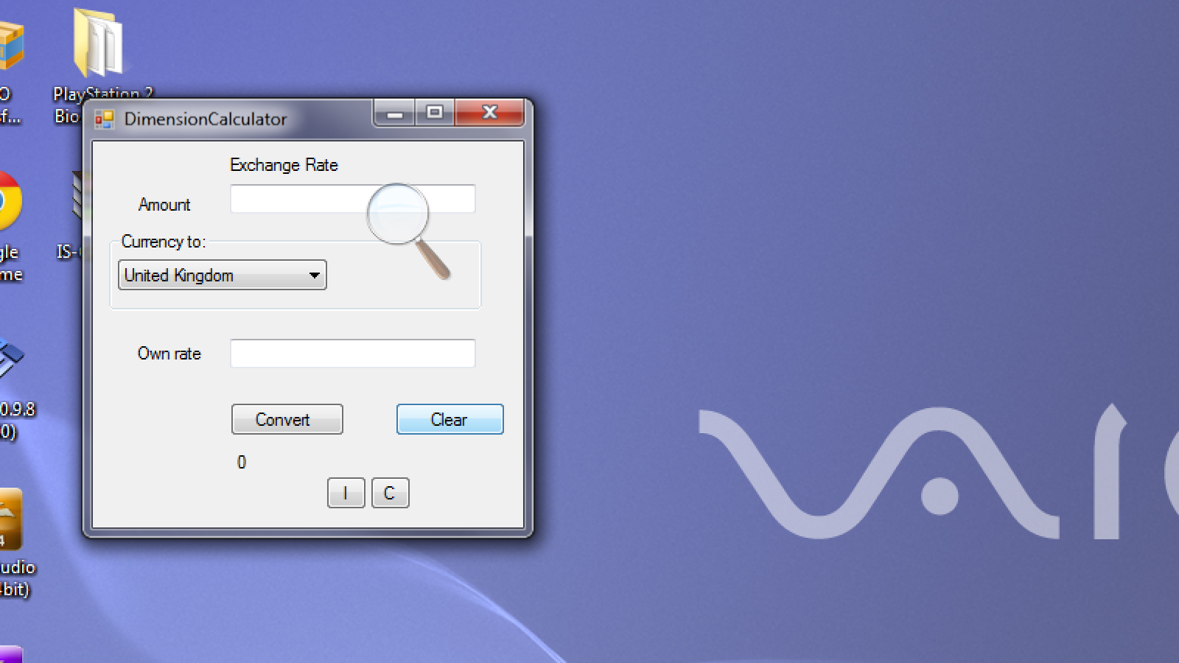

Interest Rate:

